Quiz Manager

User Understanding document

* Yogithasatyasai Pantham

**CLEAR GUIDE FOR THE USER**

1. Open Eclipse.

* Click File > Import
* Type Maven in the search box under Select an import source:
* Select Existing Maven Projects
* Click Next
* Click Browse and select the folder that is the root of the Maven project (probably contains the pom.xml file)
* Click Next
* Click Finish

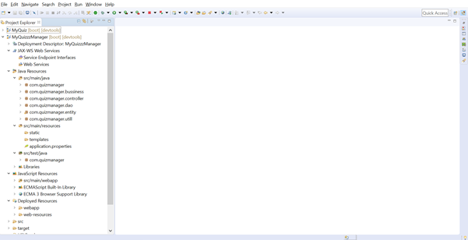

1. Open the project and execute.

* Open MyQuizzzManager -> src/main/java -> com.quizmanager.
* Open the MyQuizzzManagerApplication class file.
* sRight Click on class and Run as Java Application.

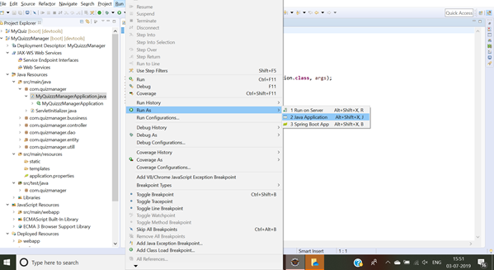

1. Step by step process of your execution.

**Step-1:**

Open the browser and copy the link 🡪 <http://localhost:8085/saveExam>

**WELCOME2QUIZ:**

Here the below image shows you the welcome page to begin quiz

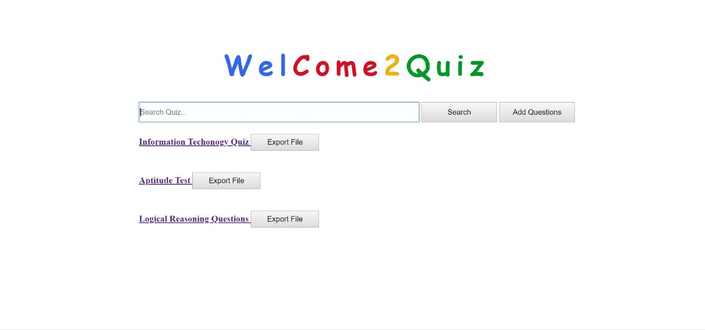

**Step-2:**

Next**:** No data exist – Type something out of the quiz and you get data not found

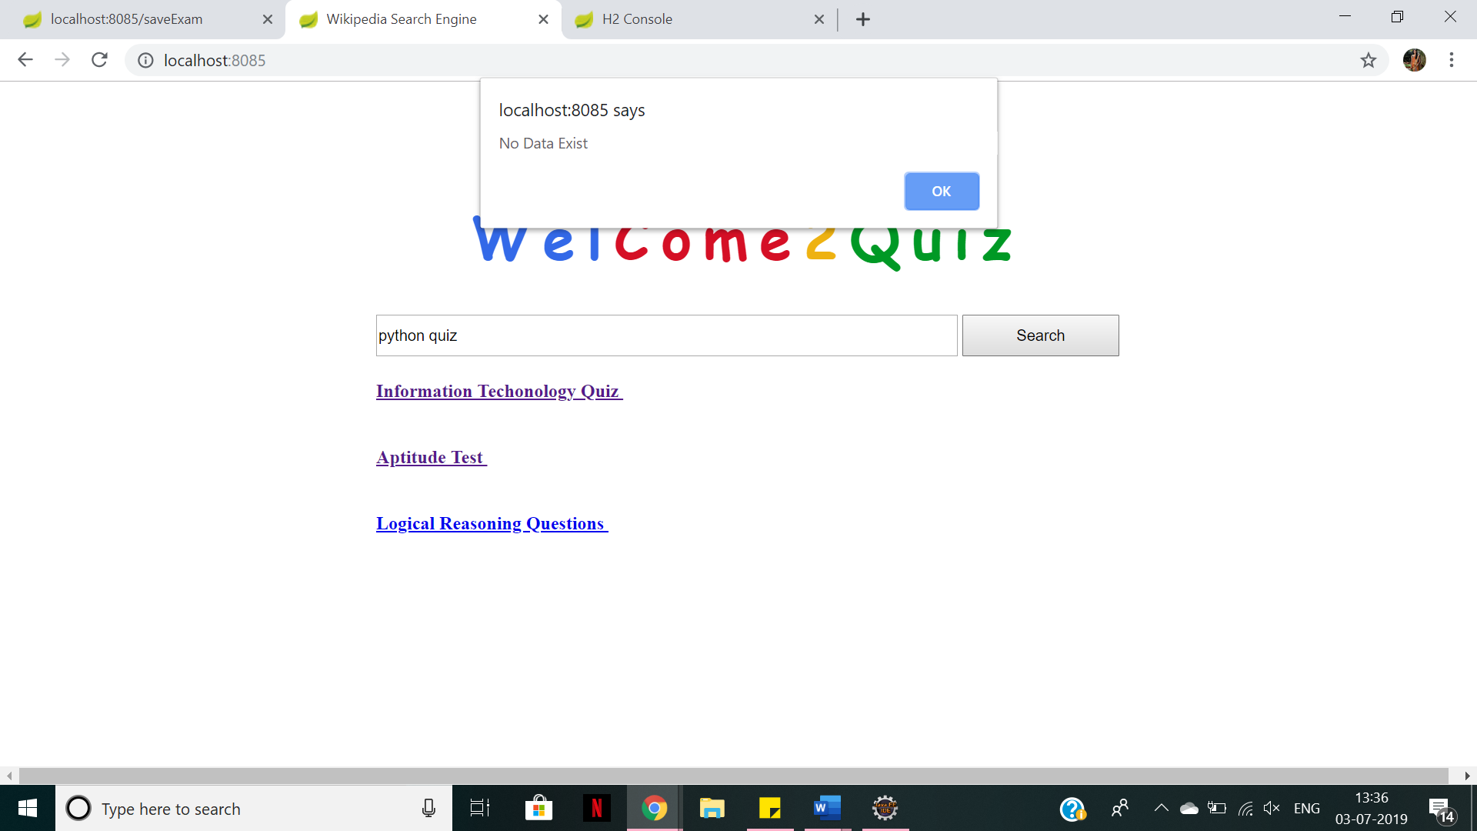

**Step-3:**

Data found: search for the related topic and you will find the data required and check.

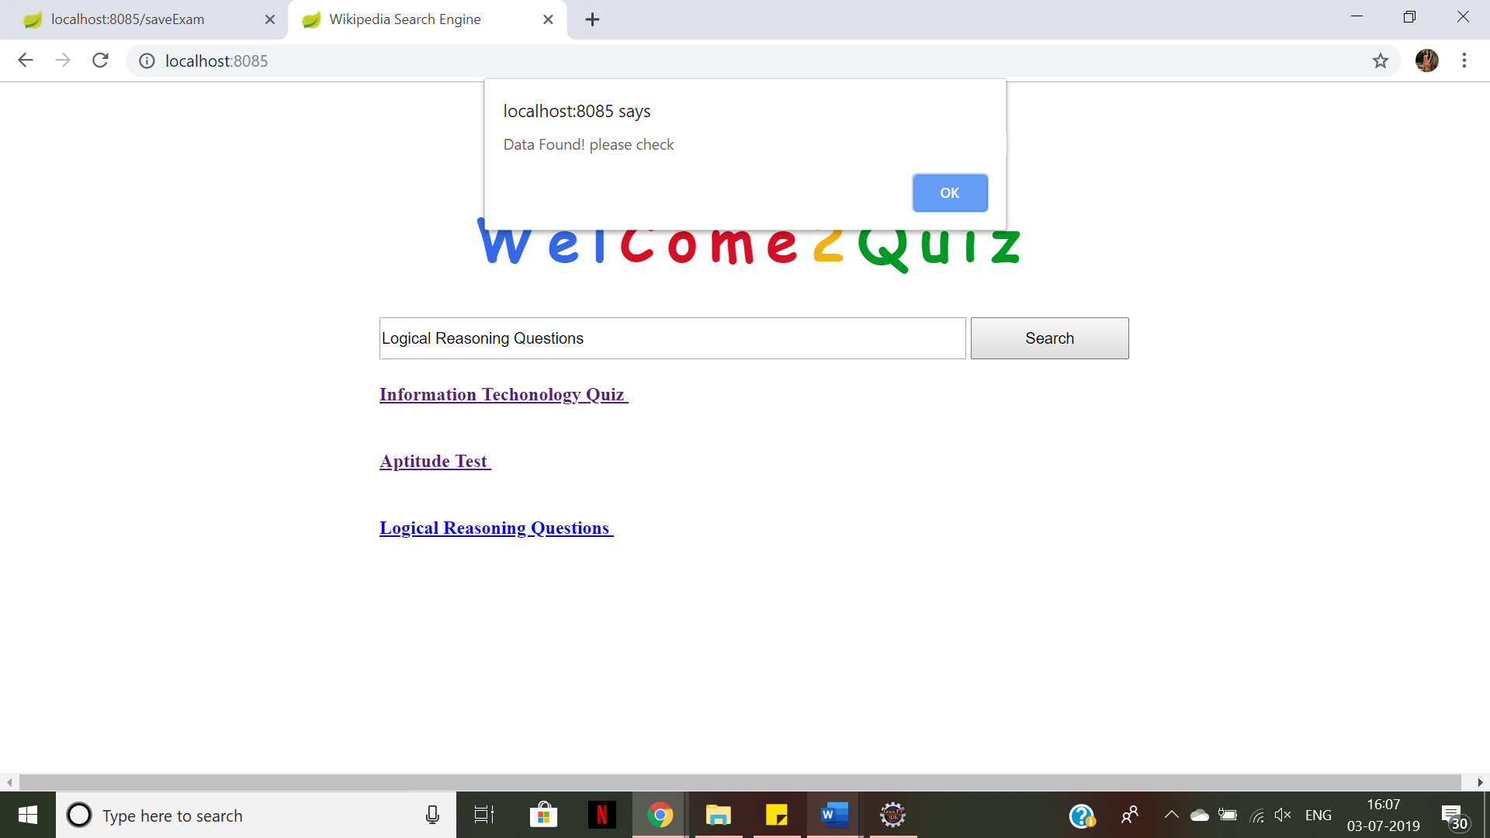

**Step-4:**

Click on Information Technology Quiz and you will be on the below page and it allows you to start the quiz

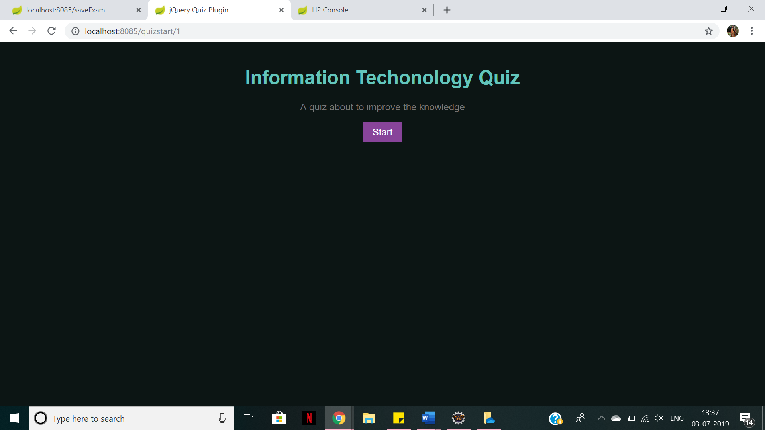

**Step-5:**

In this below image You can start the exam and proceed with your answers. If you select correct answer, it gives you in green colour.

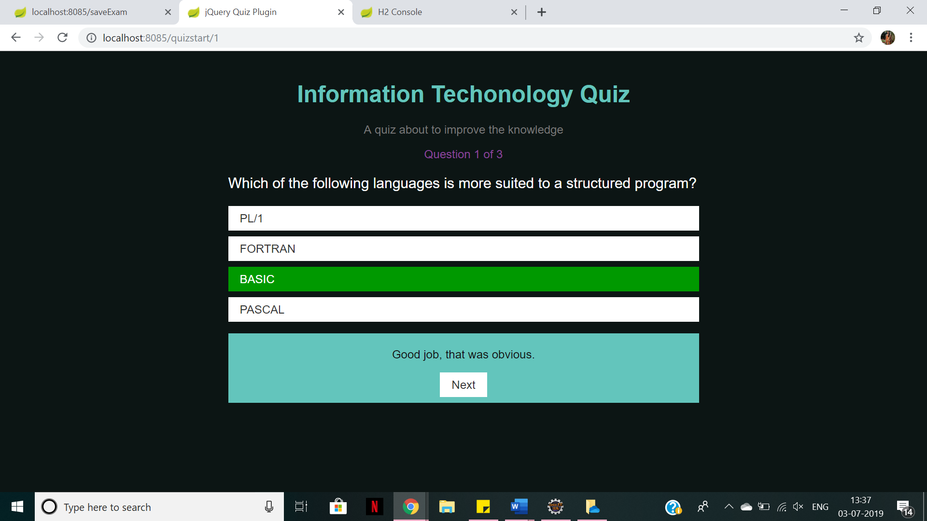

**Step-6:**

If you select a wrong answer, it will give you in red colour as shown below.

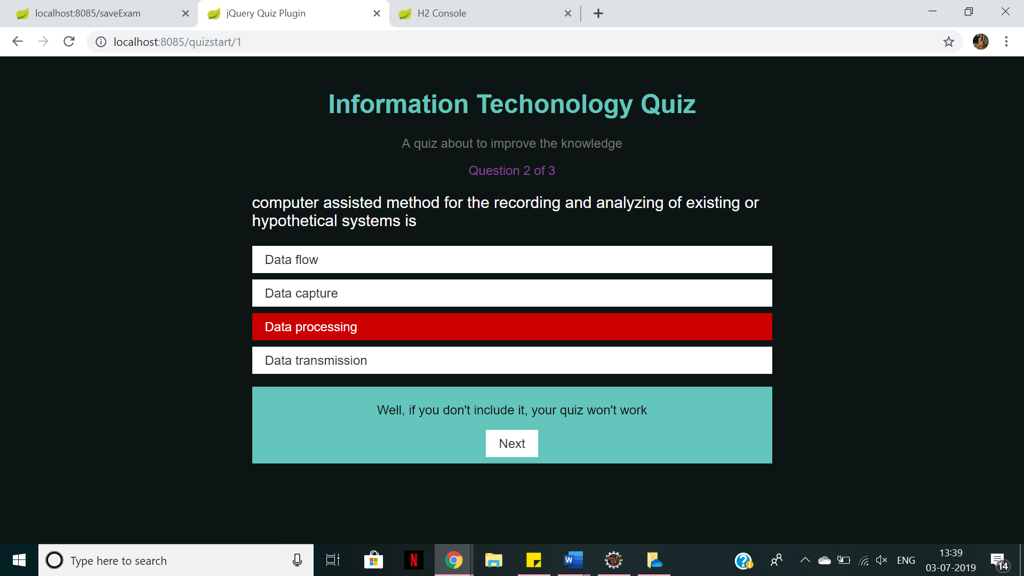

**Step-7:**

After you complete the quiz you will get a score board like this below.

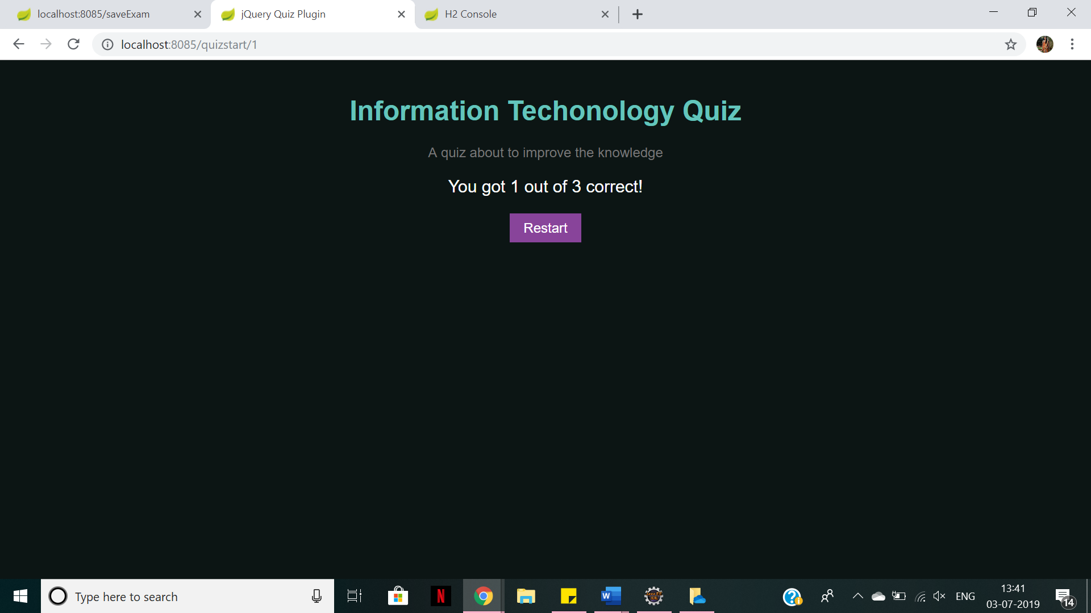

**Database details:**

1. Paste the URL : <http://localhost:8085/h2-console/>
2. Username: sa
3. Password: password

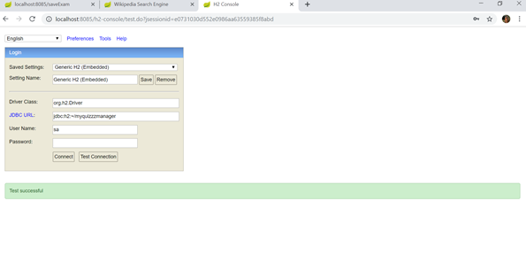

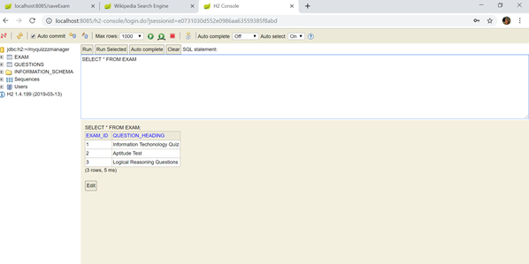

**ADD QUESTIONS:**

Click on the add questions below, so that you can add the questions.



**EXPORT FILES:**

Just click on export for exporting the files.

